- Create user with name Techie and provide sudo access to user.
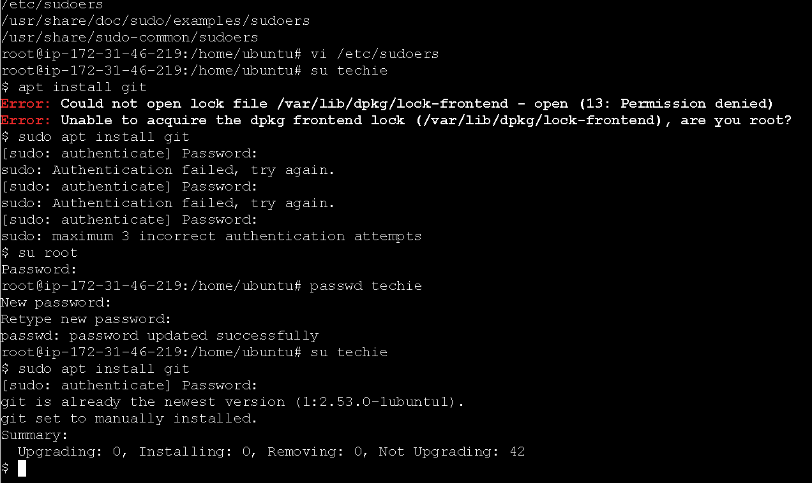
- Navigate to the home directory.
- 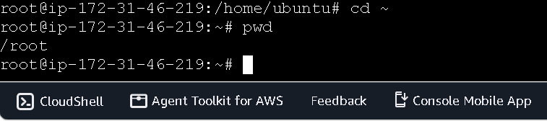
- Create a new directory.
- List the contents of a directory.
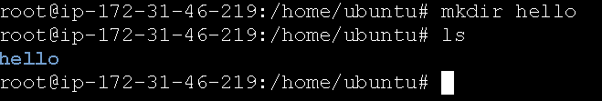
- Change the current directory.

- Create a new empty file.
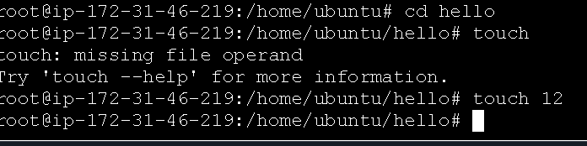
- View the contents of a file.

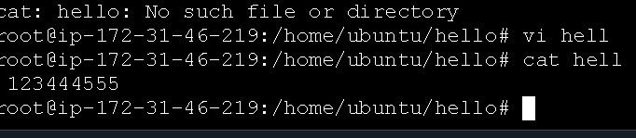
- Copy a file to another location.
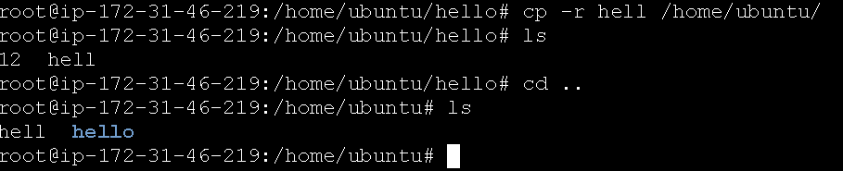
- Move a file to another location.

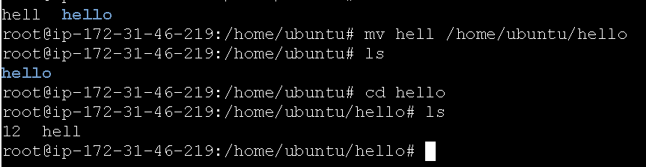
- Rename a file.

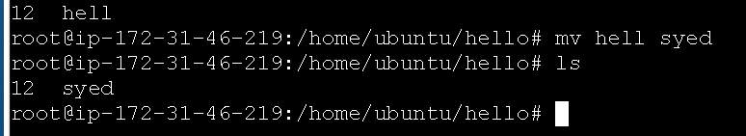
- Delete a file.

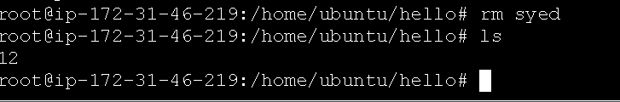

- Grant or revoke permissions on a file or directory.
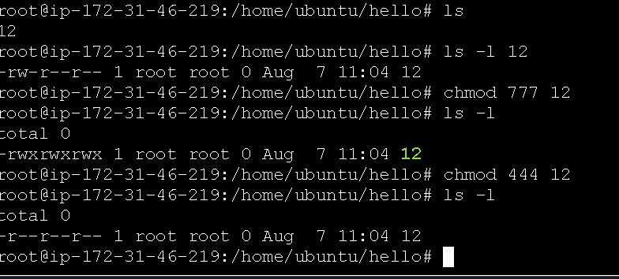
- View the current date and time.
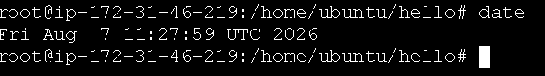
- Check the system uptime.

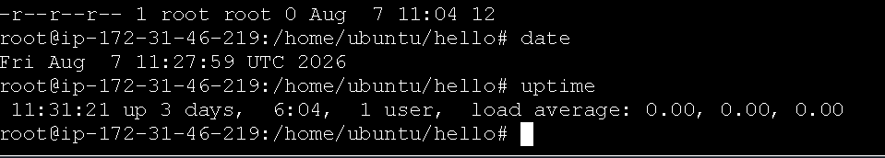
- View the running processes.
Ps-ef
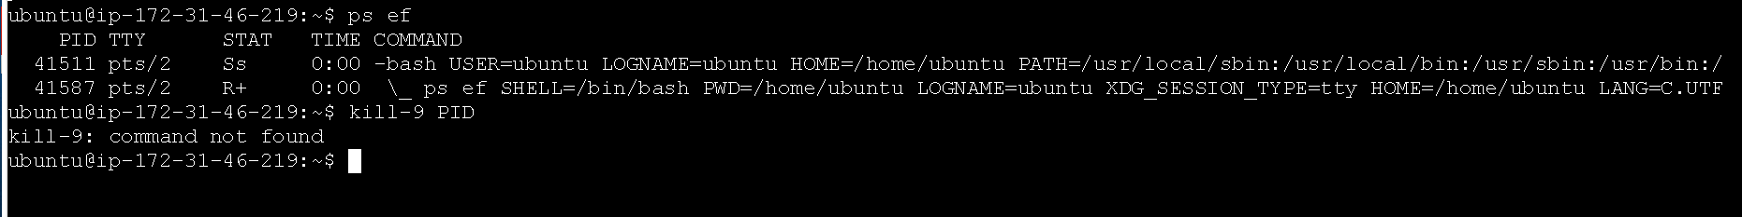

- Kill a running process.
- 

Kill -9 PID

- .
Search for files using the find command.

Find- file name
